Introduction to ITWS

Quiz 1: March 1, 2018

There are 5 questions of multiple parts. Point values and suggested times are indicated

Place your name on the top of the document in the header

Enter your answers directly into this document (with the exception of #2)

All answers should be in be in Your Own Words, and use proper grammar

Make sure your answers use an alternative font and/or color

Save the document as *yourname*-quiz1.docx (or doc)

Place all documents including this one in a folder named

ITWSQuiz1-*yourname*-*yourRCSID*

When finished with the quiz, zip your folder and all related files into a file named

ITWSQuiz1-*yourname*-*yourRCSID*.zip

And submit it to LMS

Follow all of these instructions or you will lose points

1. Network protocols, HTML & WWW : (20 points, 10 minutes)  
   1. Explain how the OSI 7-layer model is relevant to me searching the answer this question on Google. (5 points)

* 1. What is a VPN. Why do we need/use it (give an example)? (5 points).
  2. Explain the difference between a GET and a POST request, and give specific examples of their use? (5 points)
  3. What is the difference between an IRI and a URI and describe a URI’s format in detail as covered in class? (5 points)

1. HTML & CSS (40 points, 20 minutes)

Instructions to this question are contained in the HTML file in the zip folder you downloaded from LMS.

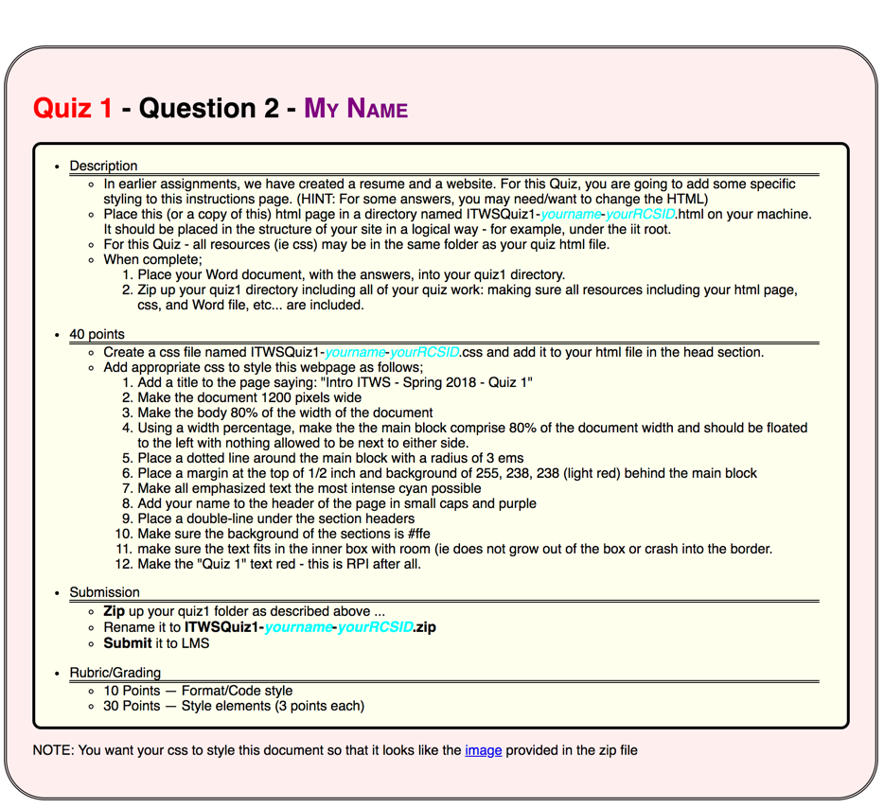

1. Communications and Networks. (20 points, 10 minutes)
   1. What is the Value of a network? What is the cost of a network? How do they relate? (Answer in complete sentences) (10 points)
   2. As discussed in class: What is Time Division Multiplexing? Why is it useful? (Answer in complete sentences) (10 points)
2. Web Science Guest Lecture (10 points, 10 minutes)
   1. What is Web Architecture? What are 3 related core standards (Answer in complete sentences) (5 points)
   2. Name at least three core principles for creating a healthy web. Why is Linking important? (Give an example) (Answer in complete sentences) (5 points)

1. “Facebook Fake News in the Post-Truth World” Case (10 points, 10 minutes)  
   1. What are network effects? Why are network effects crucial to the success of a social networking platform? (5 points)
   2. If you were to start a social networking platform tomorrow, what would your plan be for generating revenue? Why? (5 points)